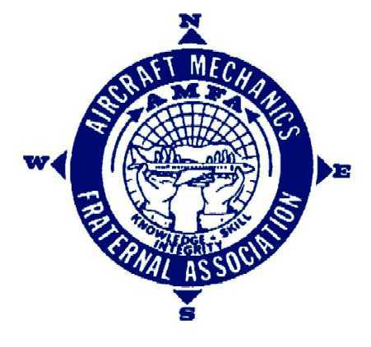Aircraft Mechanics Fraternal Association
National Office: 7825 E. Arapahoe Ct, Suite 1100 • Centennial, CO 80012
Tel: 303.752.AMFA (2632) • Fax: 303.362.7736

AMFA– SWA Facilities Maintenance Technician Negotiator

Nomination Notice & Form

AMFA National is accepting nominations for the position of AMFA-Southwest Airlines (SWA) Facilities Maintenance Technician (FMT) Member-at-Large Negotiator.

In accordance with the AMFA Constitution, eligible nominees must be employed by Southwest Airlines in the FMT classification, be active AMFA members in good standing, and have no outstanding assessments or fines owed to the National or Local.
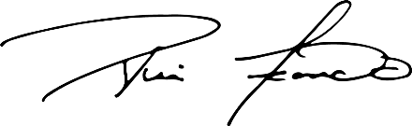
Nominations must be submitted to elections@amfanatl.org no later than 3:00PM ET, November 12, 2026.
Rui Leonardo October 30, 2026
National Secretary/Treasurer

Nomination Form
please print
I, , nominate the following member for the position of Facilities Maintenance Technician Member-at-Large Negotiator:
Nominee’s Name
Nominee’s Email Nominee’s Cell #
Nominator’s Name: AMFA#
Nominator’s Signature: Date:

